**Hotel Management System**

**(Project Plan Document)**

**Project Number**

**Group # 9**

**Submitted To:**

**Mam Sadaf Naeem**

**Project Team**

|  |  |  |  |  |
| --- | --- | --- | --- | --- |
| List | Roll # | | Names | |
| 1 | | 231400033 | | Ehtasham Maqbool |
| 2 | | 231400038 | | M. Bilal |
| 3 | | 231400126 | | Afaq Hussain |

**Submission Date**

**Dec 8, 2024Table of Contents**

**1.** **Project Scope** 3

Boundaries of the Proposed Hotel Management System 3

**Functionality Included in the System:** 3

**2.** **Work Breakdown Structure** 4

**3.** **Gantt Chart** 5

# **Project Scope**

### Boundaries of the Proposed Hotel Management System

To clearly define the scope of the proposed Hotel Management System (HMS), we will outline the key functionalities **included** in the system and also specify which functionalities will **not** be part of the system in this phase. This helps set clear expectations for both stakeholders and developers, ensuring that the system meets its goals without overreaching its capabilities.

#### **Functionality Included in the System:**

1. **Booking Management:**
   * Online reservations for guests (via website or app).
   * Reservation modifications (e.g., changing dates, canceling bookings).
   * Room availability tracking and dynamic pricing.
   * Confirmation emails or notifications sent to guests.
2. **Check-In and Check-Out Management:**
   * Guest check-in and check-out processing.
   * Room assignment based on guest preferences or availability.
   * Real-time updates to room status (occupied, vacant, etc.).
3. **Room Management:**
   * Managing room types, availability, and pricing.
   * Ability to track room maintenance requests (e.g., cleaning or repairs).
   * Room status updates (e.g., clean, dirty, under maintenance).
4. **Billing and Payment Processing:**
   * Generating invoices and receipts.
   * Integration with payment gateways for secure transactions.
   * Handling different payment methods (credit cards, online payments, etc.).
   * Payment tracking and invoicing for guests.
5. **Guest Information Management:**
   * Storing guest details (name, contact information, preferences, etc.).
   * Viewing guest history and loyalty program details.
   * Updating guest profiles for personalized services.
6. **Reporting and Analytics:**
   * Real-time reporting on occupancy rates, revenue, and booking trends.
   * Performance reports for hotel management (e.g., daily revenue, guest feedback).
   * Data analysis to support decision-making (e.g., forecasting, seasonal demand).
7. **Staff Management:**
   * Employee scheduling and task management (e.g., front desk staff, housekeeping).
   * Role-based access control for staff members (admin, receptionist, housekeeping, etc.).
   * Staff performance tracking (e.g., time taken for check-ins/check-outs, guest feedback).
8. **Guest Self-Service Options:**
   * Self-check-in/check-out via mobile app or kiosks.
   * Requesting services (e.g., extra towels, room service) through the app.
   * Viewing booking details and making payments through a guest portal.
9. **Security and Data Privacy:**
   * Encrypting sensitive guest data to protect privacy.
   * Secure login for staff with multi-factor authentication.
   * Compliance with data protection regulations (e.g., GDPR)

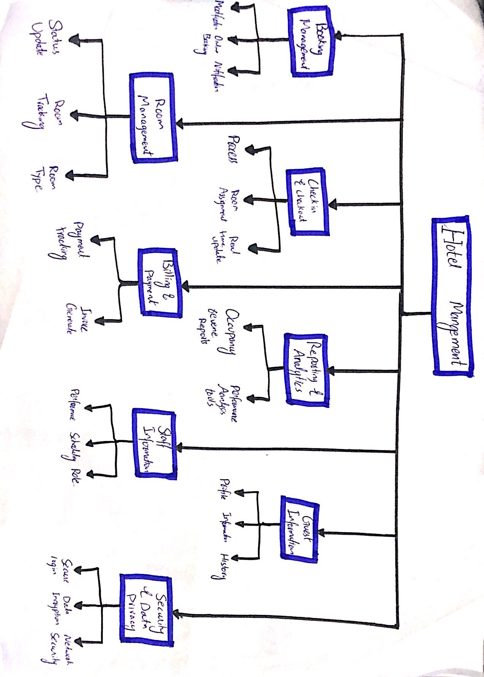

# **Work Breakdown Structure**

# **Gantt Chart**

